**GOVERNMENT COLLEGE OF ENGINEERING, KARAD**

(An autonomous institute of Govt. of Maharashtra)

VIDYANAGAR, KARAD, 415124 DIST SATARA Phone – (02164) 326632, 272414/15 Fax No. – (02164)271713

Website: [www.gcekarad.ac.in](http://www.gcekarad.ac.in)

Email: [principalgcekarad@gmail.com](mailto:principalgcekarad@gmail.com)

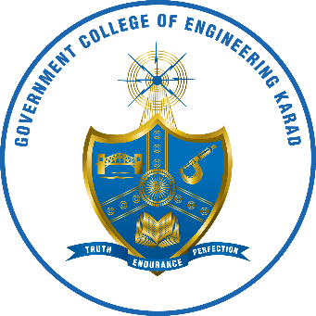

**REPORT ON**

**Faculty Advisor:**

**Student Coordinator:**

**FOR ACADEMIC YEAR 2024-25**

**• About Club:**

Pixel Club is the official photography and cinematography club of our institute, built on a shared passion for visual storytelling. From capturing college events to producing creative short films, we aim to preserve memories and narrate compelling stories through our lenses.

We manage event coverage, promotional content, and social media visuals, contributing to the institute's vibrant identity. Alongside, we conduct workshops, editing sessions, and creative challenges to help members grow both technically and artistically.

Driven by creativity, collaboration, and commitment, Pixel Club continues to be a platform where moments turn into art.

**• Events Coverd:**

* **Date : 15th August :**

The **Independence Day** was celebrated with great enthusiasm and patriotic spirit on **15th August** at **Government College of Engineering, Karad (GCEK)**.

The celebration began with the **hoisting of the National Flag** by the Principal, followed by the **National Anthem**. Faculty members, non-teaching staff, and students gathered to honor the sacrifices of our freedom fighters and celebrate the spirit of unity.

Some Photographs:

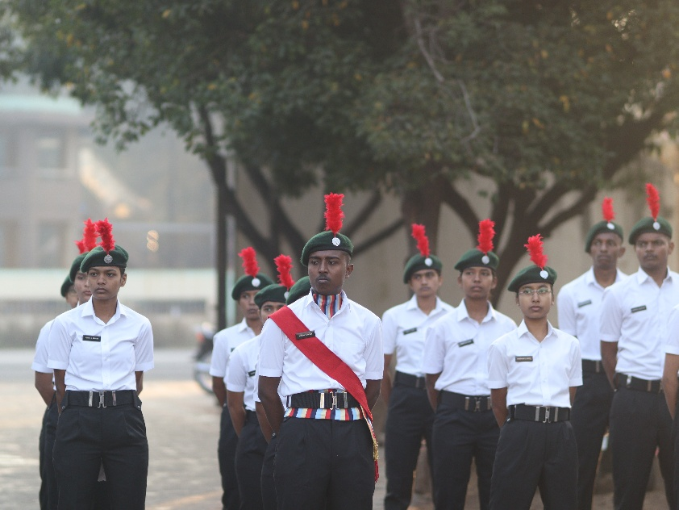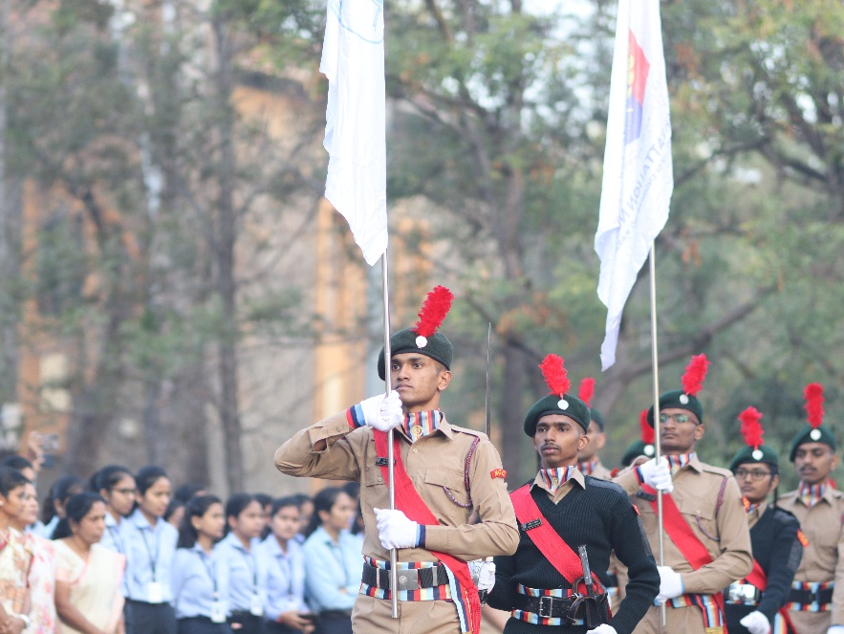

* **Date: 7th September**

**Venue: Government College of Engineering, Karad – Campas.**

The vibrant festival of **Anant Chaturdashi** was celebrated with immense enthusiasm on **7th September** at **GCEK**, marking the conclusion of the **Ganesh Utsav**. The event reflected a perfect blend of devotion, culture, and unity among students and staff.

As the official photography club of the college, **Pixel Club** had the privilege of covering the entire event, capturing the **emotions, energy, and essence** of the celebration. The day began with a soulful **aarti** of Lord Ganesha, followed by colorful **cultural performances** organized by the students. The atmosphere was filled with chants, music, and joy.

Some Photographs:

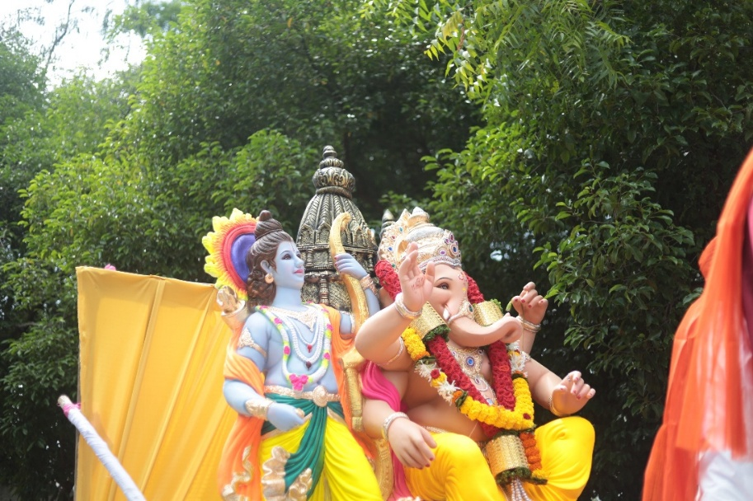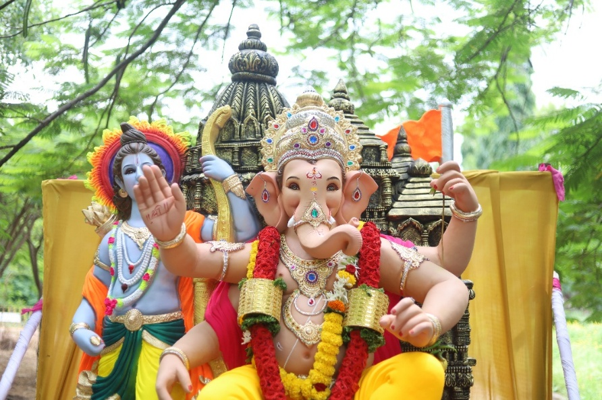

* **Date: 16th September**

**Venue: Government College of Engineering, Karad**

The **Ganesh Visarjan ceremony** at **GCEK** was held on **16th September** with great devotion and celebration, marking the conclusion of the **Ganesh Utsav** observed within the campus. The event reflected spiritual unity and cultural richness among students and faculty.

**Pixel Club**, the official photography team of GCEK, proudly documented the entire **Visarjan procession**, capturing moments of joy, energy, and reverence. The farewell to **Lord Ganesha** began with a heartfelt **aarti**, followed by a colorful procession accompanied by traditional dhol-tasha beats, dancing students, and chants of **“Ganpati Bappa Morya!”**

Some Photographs:

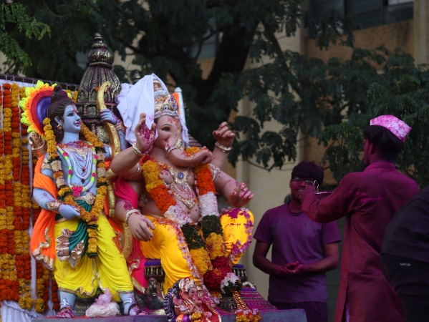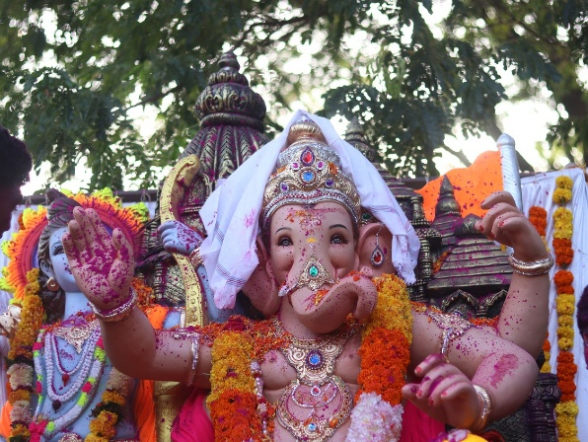

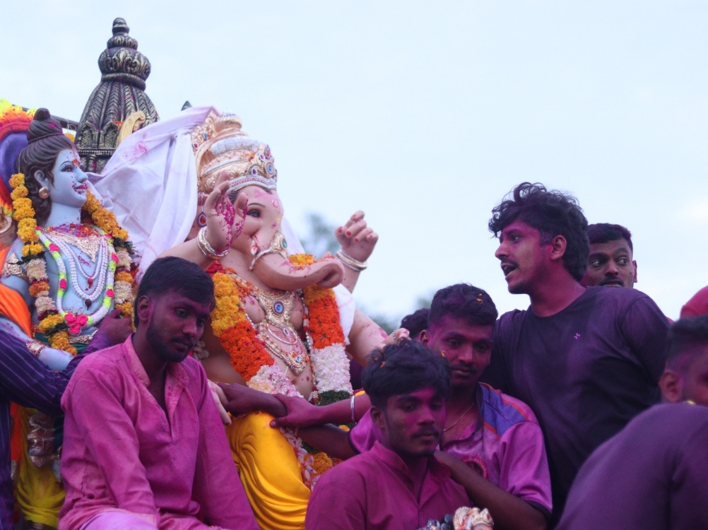

* **03rd Oct:**

On 3rd October 2024, the festival of Navratri was celebrated with great energy and enthusiasm at Government College of Engineering, Karad (GCEK). Students dressed in traditional attire participated in Garba and Dandiya Raas, lighting up the campus with festive joy and cultural pride. The event fostered a strong sense of unity and celebration among all attendees.

Pixel Club, the official photography club of GCEK, actively covered the entire event, capturing the vibrant moments, graceful dance moves, and candid expressions of joy. The team ensured that the spirit of Navratri was preserved through creative and professional photography. A photo gallery will soon be shared with the GCEK family to relive the memorable night.

Some Photographs:

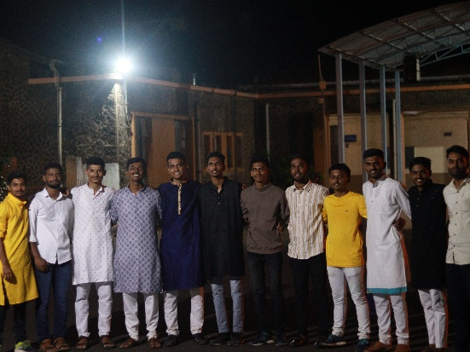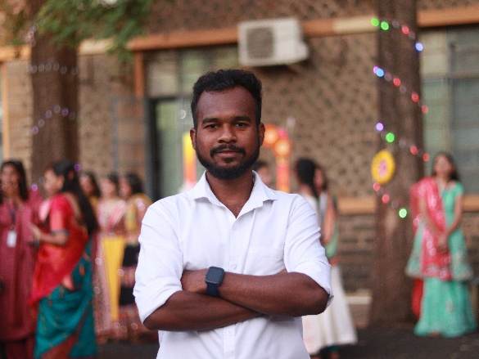

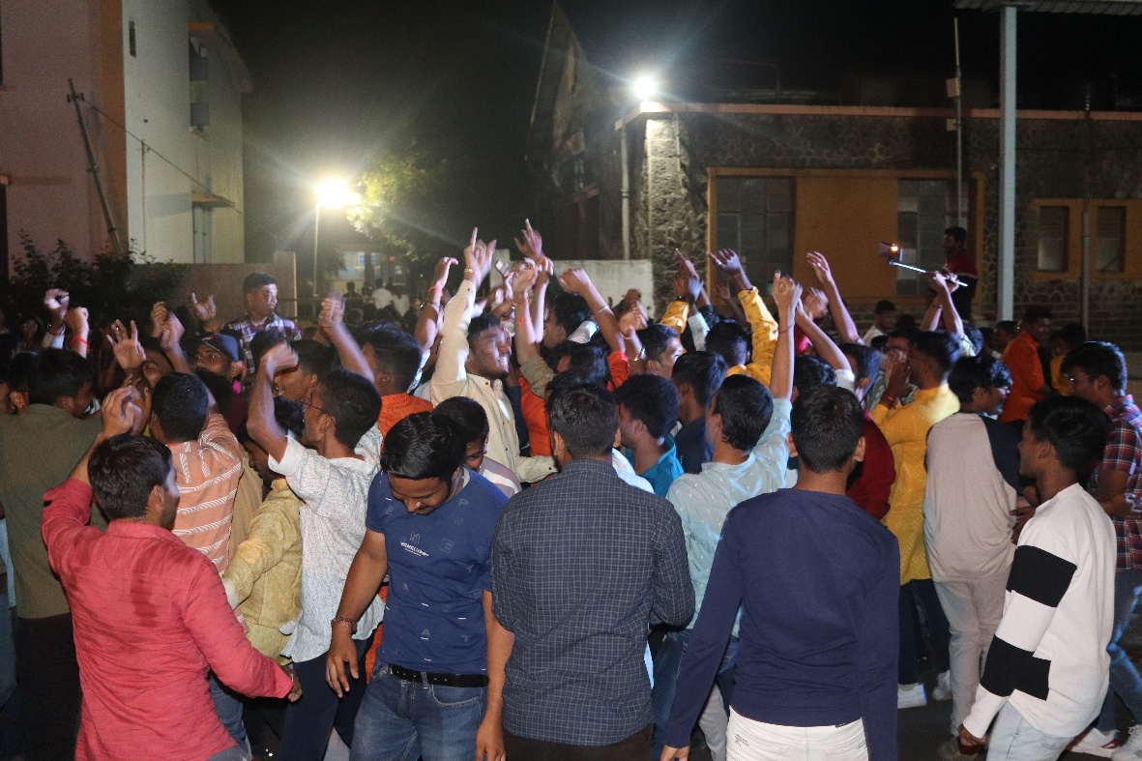

* **05th Jan – 10th :**

The Faculty Development Program (FDP) on Generative AI was held from 5th January 2025 to 10th January 2025 at the I-1 Classroom, IT Department, Government College of Engineering, Karad (GCEK). The event focused on the rapidly evolving field of Generative Artificial Intelligence, covering topics like large language models, AI tools, prompt engineering, and ethical implications. The sessions were delivered by expert speakers and witnessed active participation from faculty across multiple departments.

As the official photography club of GCEK, Pixel Club had the privilege to cover the entire program. From speaker sessions and hands-on workshops to participant engagement and closing ceremony, every significant moment was captured creatively and professionally. The Pixel Club ensured that the event’s highlights are preserved visually and will be shared with the GCEK community through a dedicated photo gallery soon.

Some Photographs:

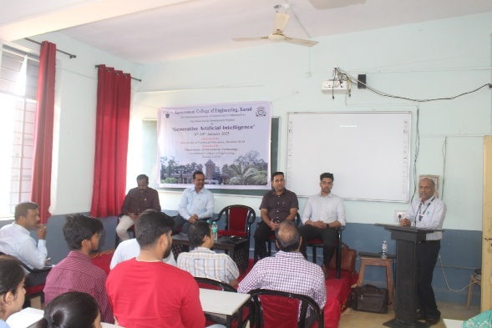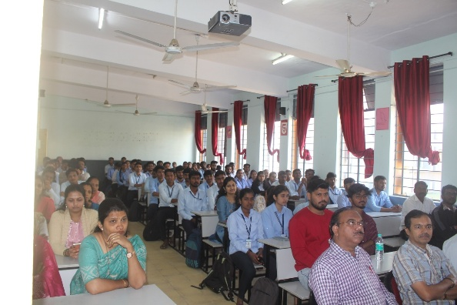

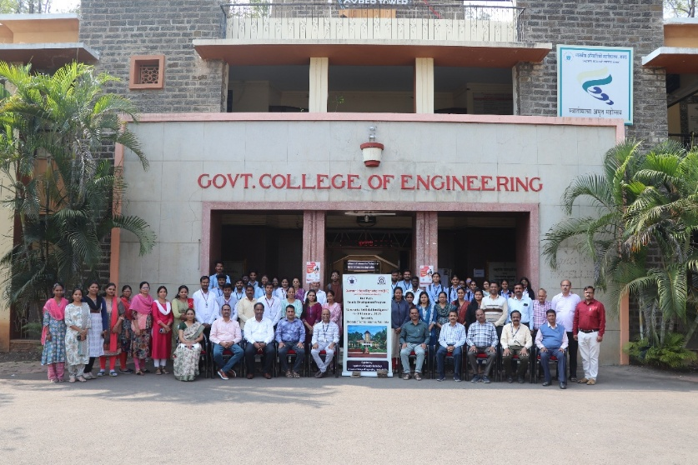

* **11th Jan 2025:**

A grand **Job Fair** was organized on **11th January 2025** by the **Training and Placement Office (TPO), Government College of Engineering, Karad (GCEK)**. The event witnessed the participation of **100+ reputed companies** across various sectors, offering a wide range of career opportunities to final-year students. The fair served as a dynamic platform for students to interact with industry professionals, attend interviews, and explore real-world job prospects, all within the GCEK campus.

**Pixel Club** actively documented the energy and professionalism of the day through thoughtful photography. From capturing the confident expressions of job aspirants to the welcoming booths of recruiters, the team focused on showcasing the scale and success of the event. Each frame was aimed at highlighting the spirit of ambition, preparation, and hope that defined the Job Fair 2025. A photo gallery will soon be shared to commemorate this milestone event.

Some Photographs:

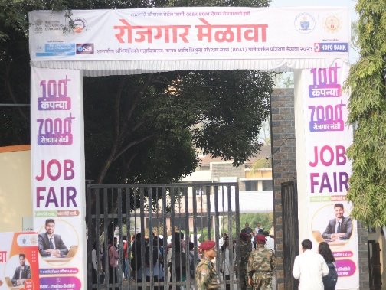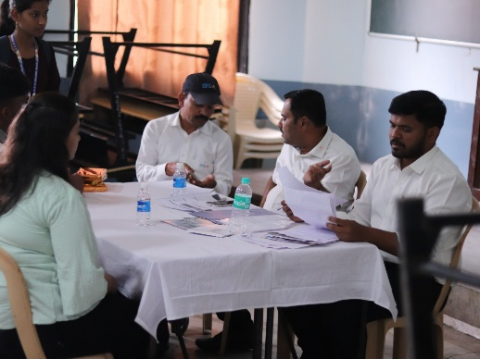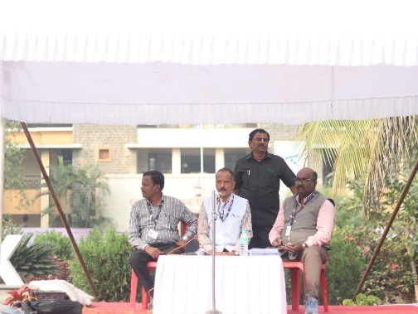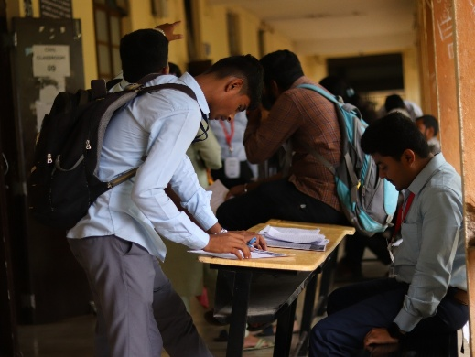

* **26th Jan 2025:**

The **76th Republic Day** was celebrated with pride and patriotism on **26th January 2025** at **Government College of Engineering, Karad (GCEK)**. The event began with the flag hoisting by respected dignitaries, followed by the national anthem and speeches highlighting the importance of the Constitution and India’s democratic journey. Cultural programs, patriotic songs, and student performances added to the vibrant spirit of the occasion.

**Pixel Club**, with its keen eye and creative lens, captured not just the event but the **emotion of patriotism** reflected in every face. From the fluttering tricolor against the sky to candid frames of audience engagement and backstage energy, the team focused on storytelling through visuals. This special coverage aims to reflect the soul of Republic Day at GCEK — dignified, proud, and united.

Some Photographs:

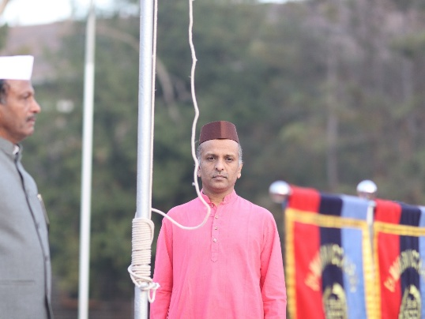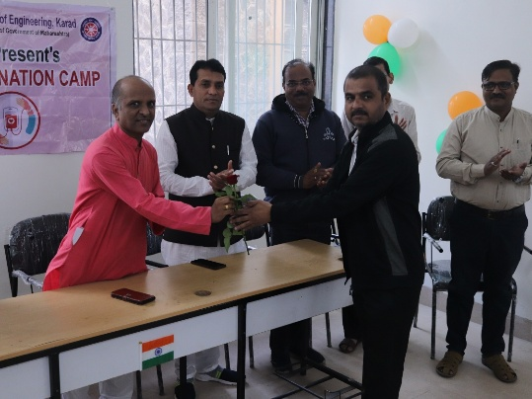

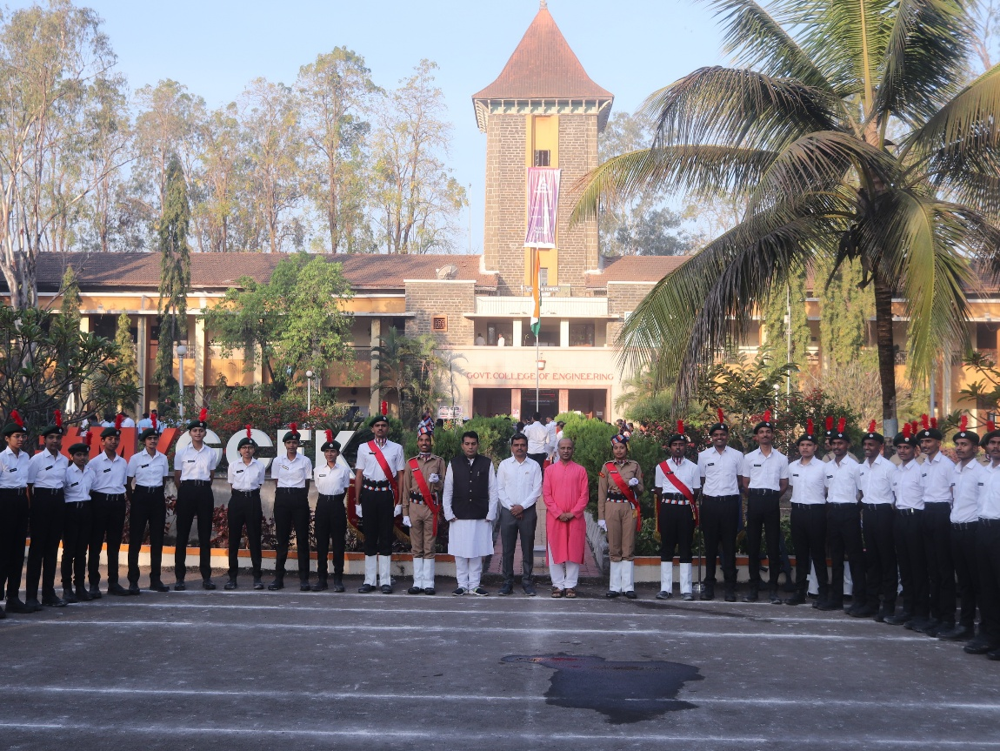

* **07th Feb 2025:**

The spirit of culture and heritage came alive on **7th February 2025** as **Traditional Day** was celebrated with great enthusiasm at the **Open Theatre, Government College of Engineering, Karad (GCEK)**. Students and faculty dressed in vibrant traditional attire representing diverse Indian cultures, turning the venue into a colorful and joyous space. The event featured traditional music, ramp walks, and energetic performances that highlighted India’s unity in diversity.

Unlike any regular day of photography, **Pixel Club** embraced this celebration as a chance to capture the essence of **Indian tradition through the lens**. The open theatre’s natural lighting, colorful attires, and spontaneous moments offered a perfect backdrop for creative photography. Pixel Club focused on portraying not just outfits, but the pride and elegance with which each culture was represented. The photo highlights will soon be shared to relive these beautiful moments.

Some Photographs :

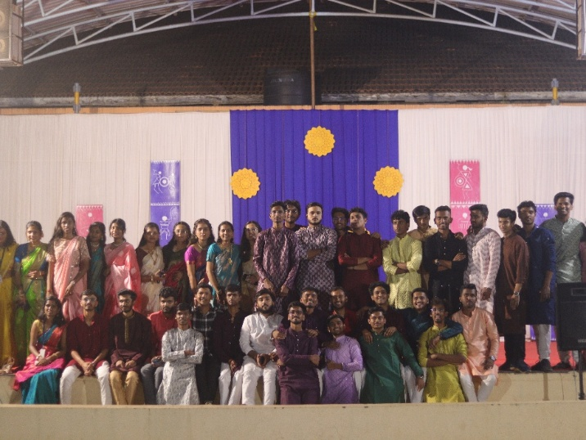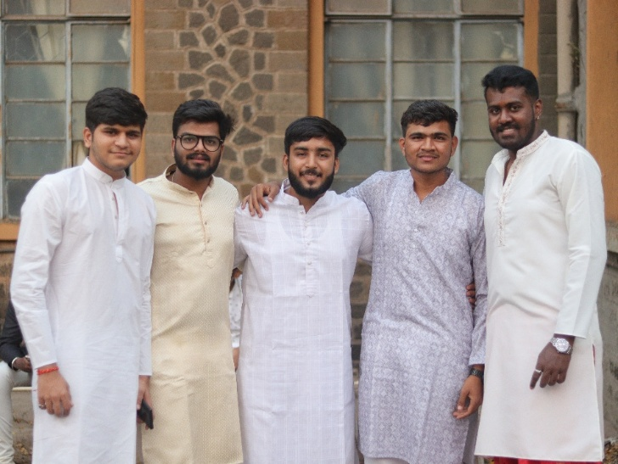

* **16th , 17th & 18th Feb 2025 :**

**Aavishkar 2025**, a prestigious **national-level technical and non-technical event**, was successfully conducted on **16th, 17th, and 18th February 2025** at **Government College of Engineering, Karad (GCEK)**. The event attracted enthusiastic participation from students across the country, featuring a wide range of competitions including coding challenges, robotics, quizzes, debates, cultural showcases, and fun-filled games. Aavishkar stood as a testament to GCEK's commitment to innovation, talent, and vibrant student culture.

With the scale and spirit of the event at its peak, **Pixel Club** took on the massive responsibility of covering every electrifying moment. From the technical adrenaline in coding rooms to the cheers in non-technical arenas, the team captured the true essence of Aavishkar through dynamic and expressive visuals. Every photo told a story — of effort, passion, and celebration. A curated gallery of this grand event will soon be released for everyone to relive the excitement and brilliance of Aavishkar '25.

**Some Photographs :**

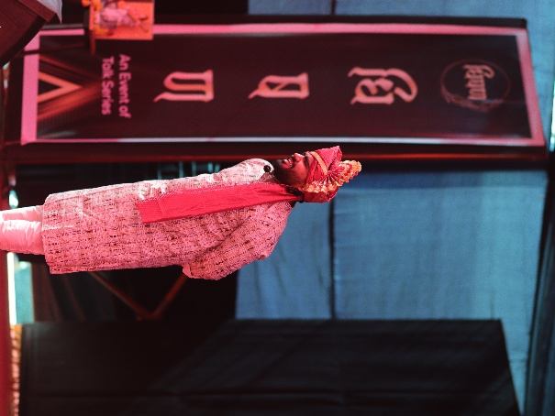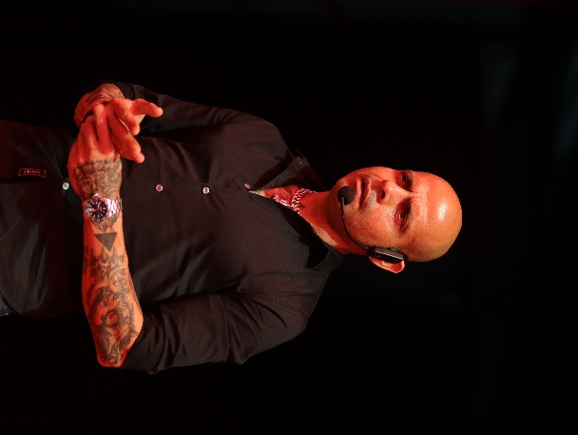

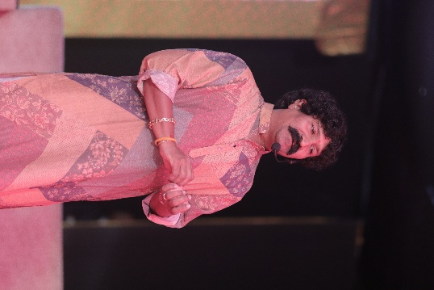

* **Airaawat – Weapon Display Event**

Airaawat, the weapon display event held at Government College of Engineering, Karad (GCEK), offered students and faculty a rare glimpse into the defense sector and its arsenal. The exhibition showcased various weapons and equipment used by the Indian Armed Forces, fostering awareness, patriotism, and curiosity among attendees. Experts provided live demonstrations and insightful explanations, making it an informative and inspiring experience for all.

Pixel Club actively captured the impactful moments of Airaawat, focusing on the intricate details of the weapons, the enthusiasm of the visitors, and the pride of the organizers. Through high-quality frames and candid clicks, the club successfully preserved the essence of this powerful event, creating a strong visual narrative that reflects discipline, strength, and national pride.

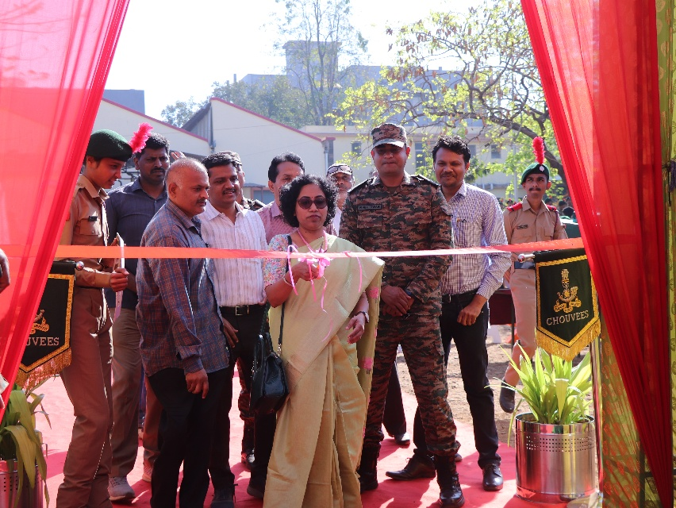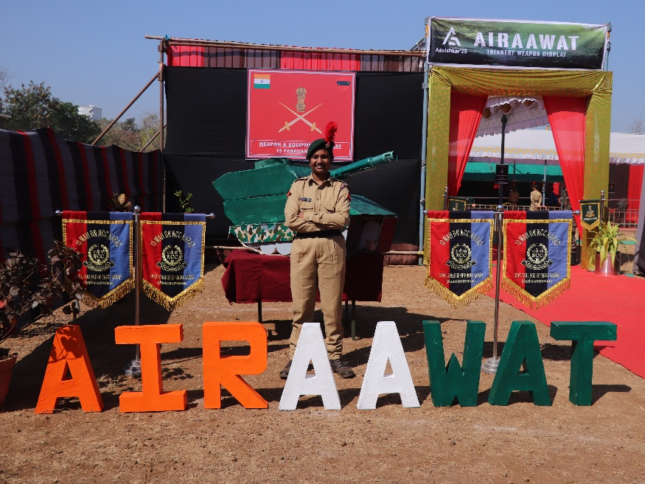

* **19th Feb 2025:**

On 19th February 2025, Shiv Jayanti was celebrated with great pride and enthusiasm at Government College of Engineering, Karad (GCEK) to honor the birth anniversary of Chhatrapati Shivaji Maharaj, the legendary Maratha king. The event included inspiring speeches, traditional lezim performances, dhol-tasha, and a cultural tribute showcasing Shivaji Maharaj’s valor and leadership. Students and faculty gathered in large numbers to pay homage and celebrate the rich Maratha heritage.

Pixel Club beautifully documented the vibrant and powerful atmosphere of the celebration. The thundering beats of dhol, colorful traditional attire, and proud expressions were all captured in stunning frames. The team focused on highlighting the cultural essence and emotions of the day, making every photo a tribute in itself to the great warrior king. The captured moments will soon be shared with the GCEK community to relive this powerful celebration.

**Some Photographs :**

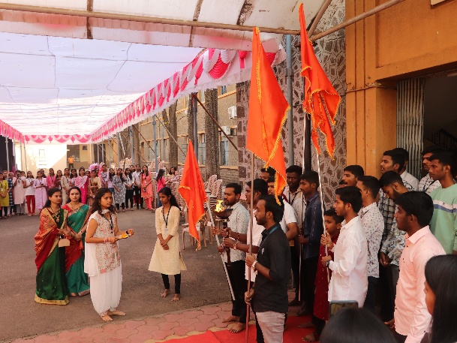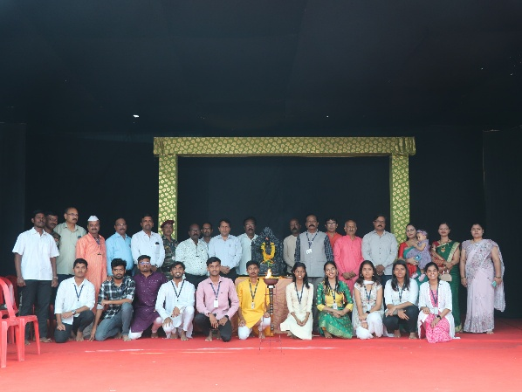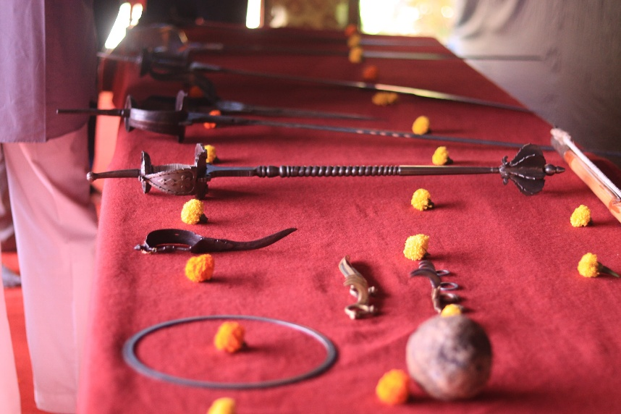

* **20th Feb 2025 – Annual Day – Inauguration:**

**10:30 AM to 11:00 AM**

The **Annual Day Inauguration Ceremony** at **Government College of Engineering, Karad (GCEK)** was held with grandeur and pride, marking the beginning of a series of cultural and technical celebrations. The event commenced with the lighting of the traditional lamp, followed by inspiring speeches from the Principal and esteemed guests. Their words reflected the college’s growth, student achievements, and the importance of holistic development through such events.

**Pixel Club** beautifully captured the inauguration moments — from the dignitaries on stage to the excitement in the audience. The atmosphere, filled with enthusiasm and elegance, was framed through vivid and professional photography. The team ensured that every moment from this special beginning was documented with clarity and grace, preserving the essence of GCEK’s Annual Day 2025.

**Some Photographs:**

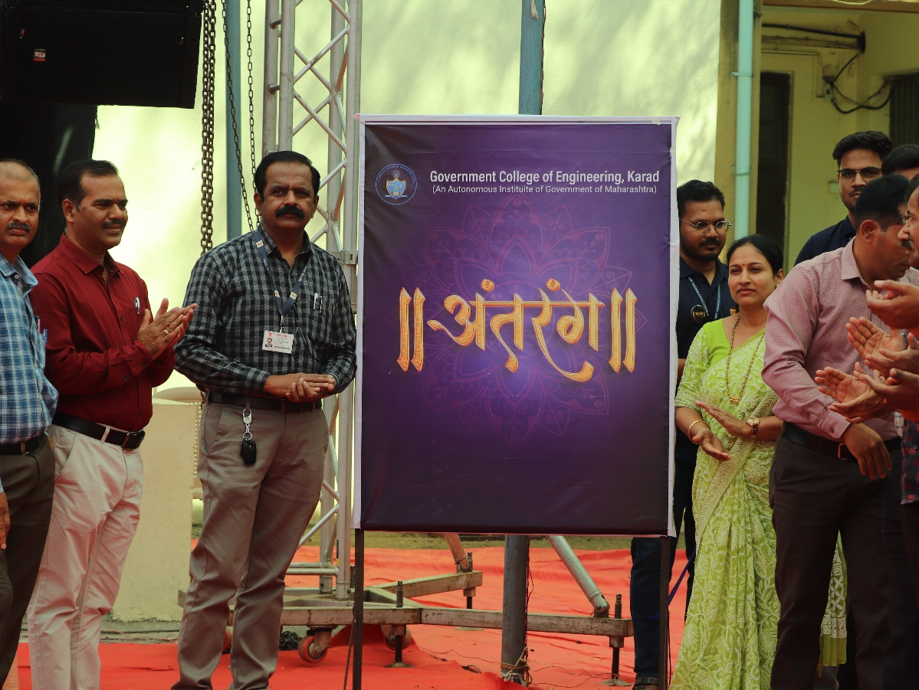

* **20th Feb 2025 – Annual Day – Flashmob:**

**11:00 AM to 12:00 PM – OT**

As a thrilling surprise element of the **Annual Day 2025** celebrations, a high-energy **Flashmob** was performed by students in the central courtyard of **Government College of Engineering, Karad (GCEK)**. The sudden burst of coordinated dance moves and upbeat music caught the attention of everyone present, filling the atmosphere with excitement and cheers. The performance blended various dance styles and was a perfect example of unity, spontaneity, and youthful energy.

**Pixel Club** was right in action, capturing the expressions of surprise, joy, and admiration from the audience, along with the dynamic moves of the dancers. The photographs reflected the energy, rhythm, and spirit of celebration that the flashmob brought to campus. Their coverage ensured that this electrifying moment would be remembered as one of the most energetic highlights of Annual Day 2025.

**Some Photograph:**

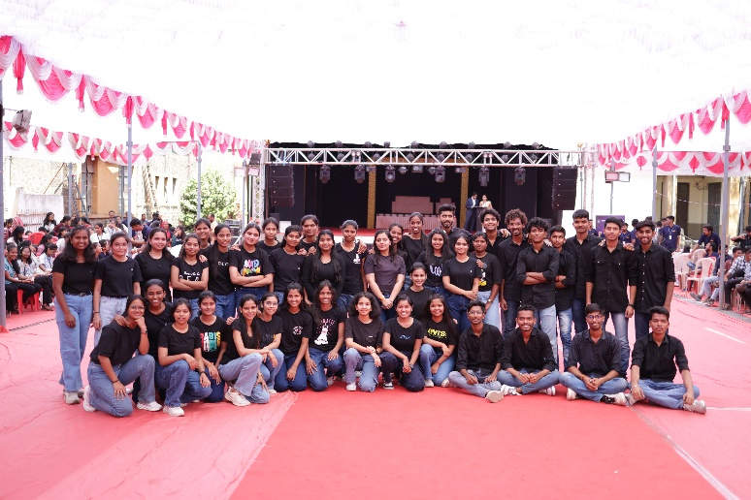

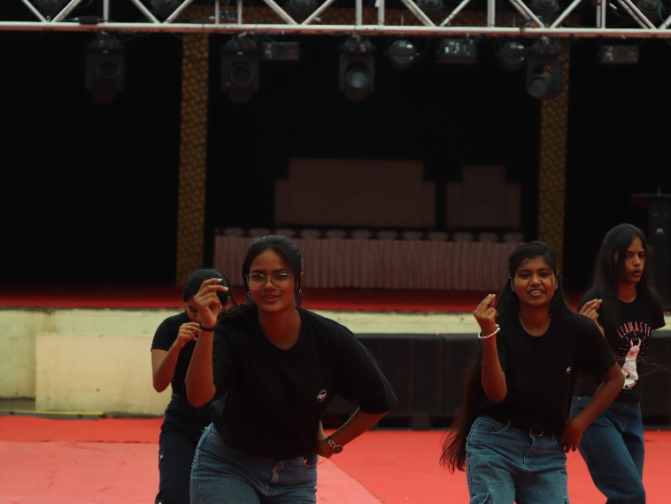

* **20th Feb 2025 – Annual Day – GCEK’s Got talent:**

**01:00 PM to 03:00 PM – GCEK Auditorium**

The Annual Day Celebration 2025 was held on 20th February at 6 PM at the Government College of Engineering, Karad (GCEK), bringing together vibrant performances and artistic brilliance under the banner of "Natyaranjan". Students showcased various cultural talents, but the highlight of the evening was the dramatic act "नजरकैद", which left the audience emotionally moved with its powerful storyline, gripping performances, and impactful stage presence.

Pixel Club, the official photography team of GCEK, captured the magic of the evening through their creative lens. From the energy backstage to the emotions on stage, each shot told a story of dedication, creativity, and celebration. The act "नजरकैद" was framed in dramatic compositions that perfectly reflected the mood and intensity of the play. The club's coverage helped immortalize these unforgettable moments of Annual Day 2025.

**Some Photographs :**

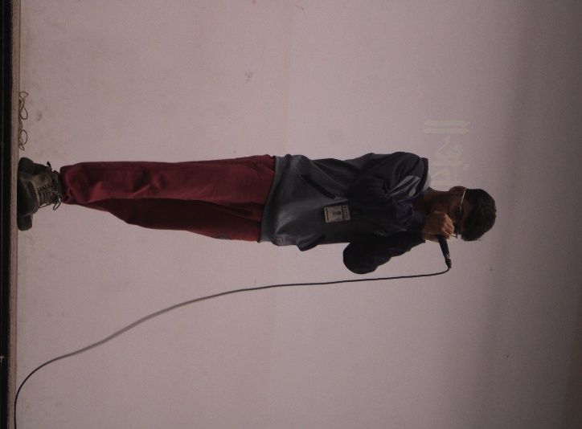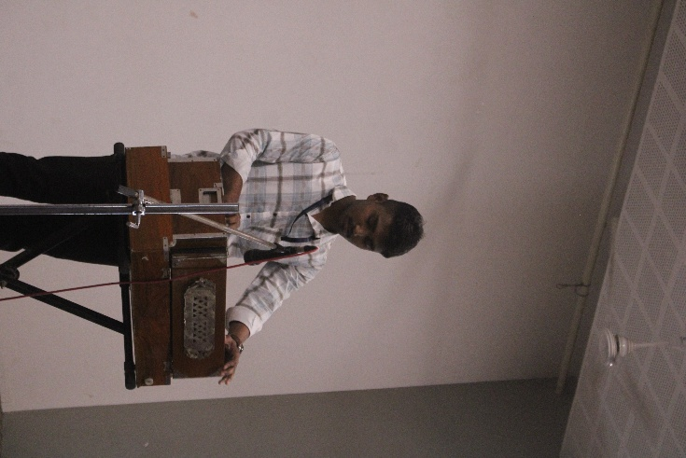

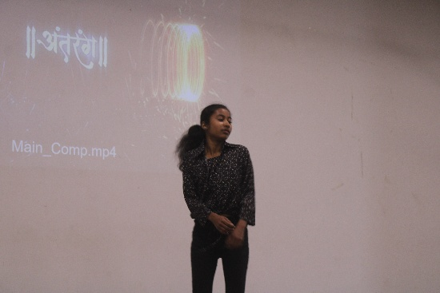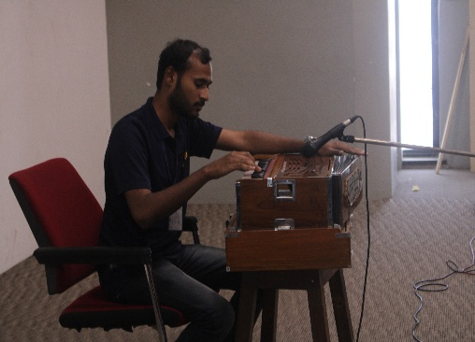

* **20th Feb 2025 – Annual Day – Natyaranjan :**

**06:00 PM to 8:30 PM - OT**

The Annual Day Celebration 2025 was held on 20th February at 6 PM at the Government College of Engineering, Karad (GCEK), bringing together vibrant performances and artistic brilliance under the banner of "Natyaranjan". Students showcased various cultural talents, but the highlight of the evening was the dramatic act "नजरकैद", which left the audience emotionally moved with its powerful storyline, gripping performances, and impactful stage presence.

Pixel Club, the official photography team of GCEK, captured the magic of the evening through their creative lens. From the energy backstage to the emotions on stage, each shot told a story of dedication, creativity, and celebration. The act "नजरकैद" was framed in dramatic compositions that perfectly reflected the mood and intensity of the play. The club's coverage helped immortalize these unforgettable moments of Annual Day 2025.

**Some Photographs:**

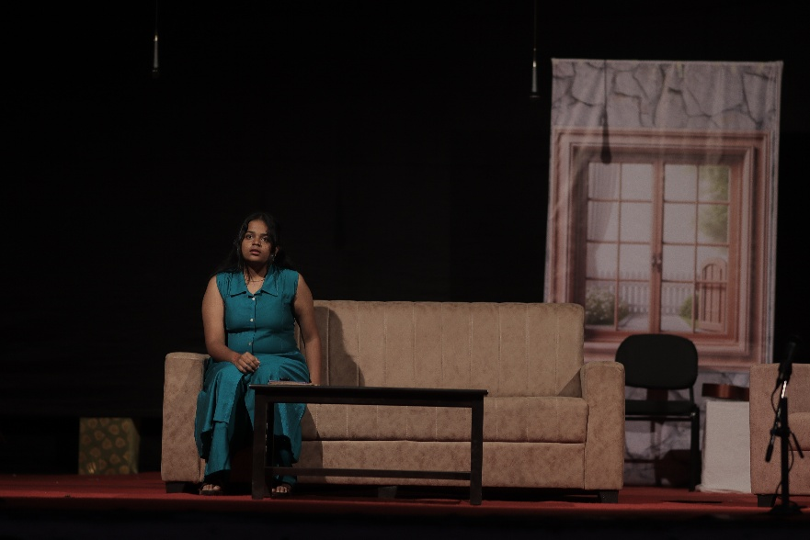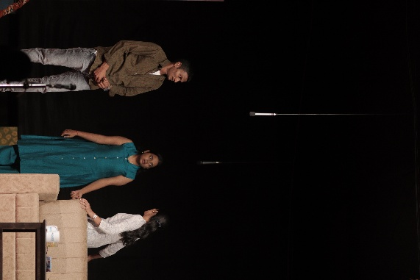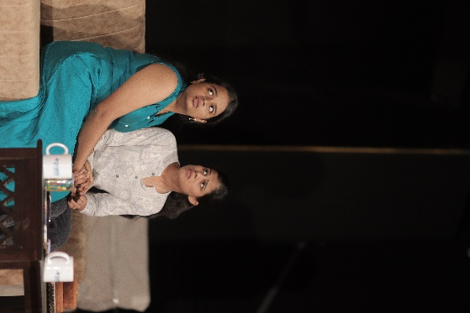

* **21st Feb 2025 – Annual Day – Guest Performance:**

**10:00 AM to 01:00 PM - OT**

The highlight of **Annual Day 2025** at **Government College of Engineering, Karad (GCEK)** was the grand **Guest Performance** held on **21st February 2025**. The event witnessed the presence of renowned personalities – **Avdhooth Gandhi**, known for his powerful musical performances, and **Mrunmai Deshpande**, a celebrated actress admired for her graceful stage presence. Their electrifying performances and heartfelt interactions left the audience inspired, entertained, and full of joy.

**Pixel Club** captured the glamour and energy of this star-studded evening with finesse. Every smile, performance, and audience reaction was documented with artistic precision. The club’s photography preserved the charm and excitement of the event, ensuring the memories of this unforgettable night with Avdhooth Gandhi and Mrunmai Deshpande remain etched in the hearts of GCEK students and faculty

**Some Photographs:**

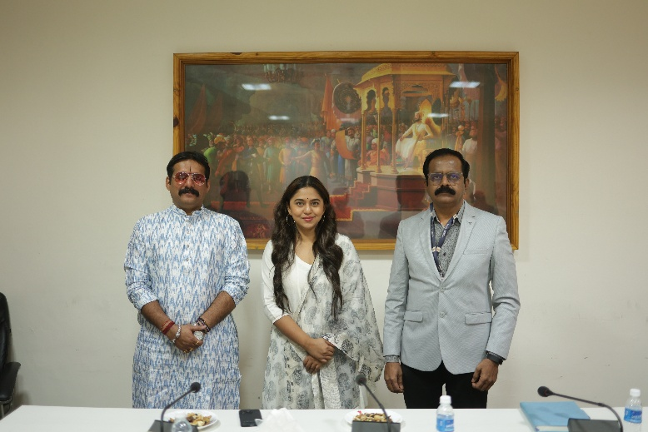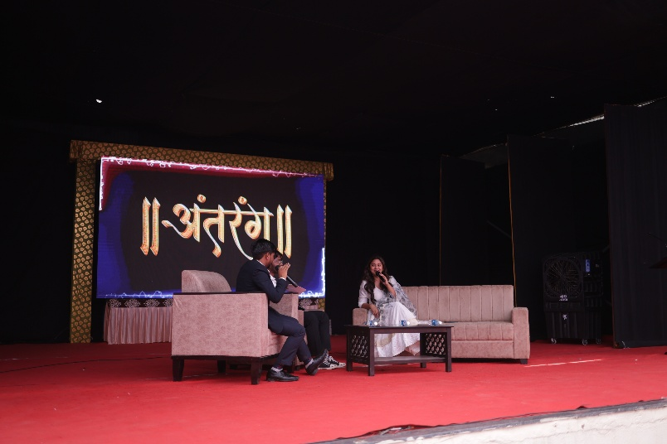

* **21st Feb 2025 – Annual Day – Abhiroop:**

As part of **Annual Day 2025** at **Government College of Engineering, Karad (GCEK)**, the drama team staged a thought-provoking act titled **"Abhiroop "** on **21st February 2025**. Set in a courtroom-style setup, the performance boldly portrayed students questioning the education system and the role of teachers. The act presented a fictional courtroom where students directly addressed their teachers with challenging questions, sparking introspection and discussion among the audience. With intense dialogues and a meaningful message, the drama left a powerful impact.

**Pixel Club** artistically captured the emotions, expressions, and intensity of this unique performance. From the gripping student-teacher confrontations to the silent moments of reflection, every scene was framed with depth and clarity. Their visual coverage preserved the essence of **"Abhiroop "**, a performance that blended creativity with a strong social message.

**Some Photographs :**

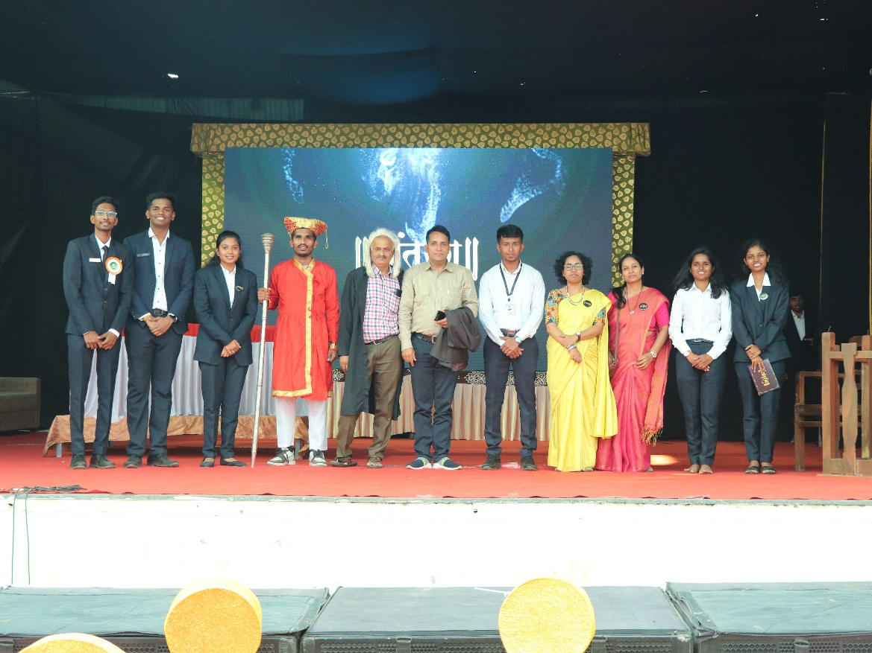

* **21st Feb 2025 – Swartarang :**

Swartarang 2025, the soulful singing and instrumental competition, was held on 21st February 2025 at Government College of Engineering, Karad (GCEK). The event brought together melodious voices and talented musicians who mesmerized the audience with their performances. From classical renditions to modern tunes, every performance showcased immense dedication, skill, and musical passion, turning the evening into a celebration of sound and rhythm.

Pixel Club gracefully captured the essence of Swartarang through expressive frames — from the intensity of vocalists to the harmony of instrumentalists. Every beat, every note, and every heartfelt expression was frozen in time through their lenses. The photographs not only documented the competition but also echoed the vibrant musical energy that defined Swartarang 2025.

**Some Photographs :**

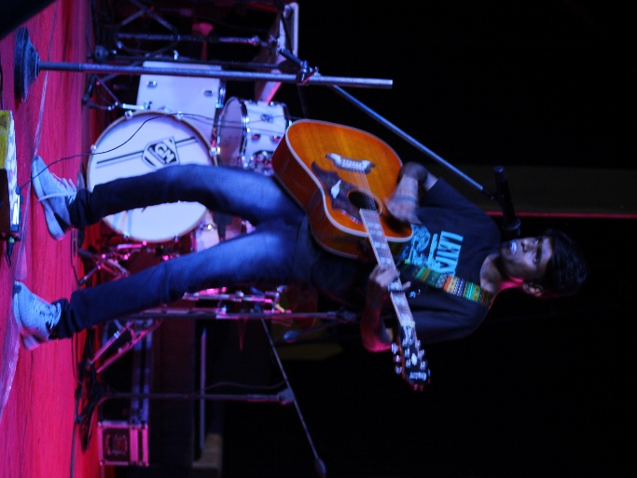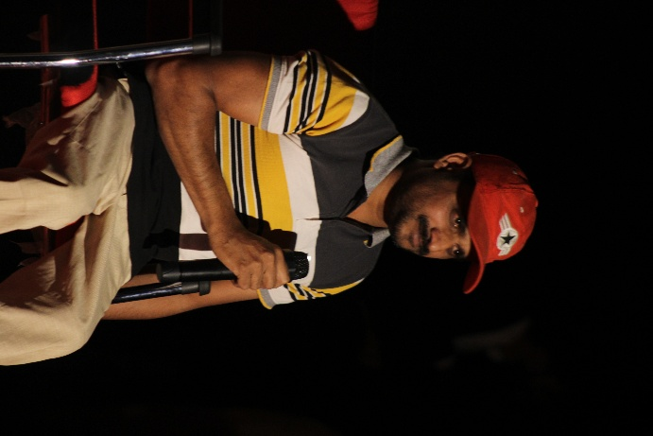

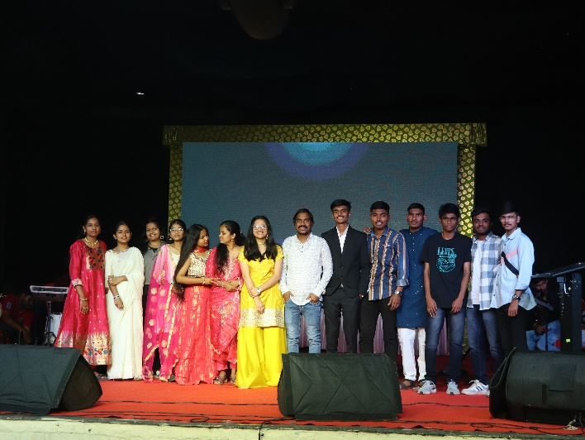

* **22nd Feb 2025 Annual Day – Nurtyaavishkar :**

"Nrutya Aavishkar", the dynamic dance competition at Government College of Engineering, Karad (GCEK), showcased vibrant talent and boundless energy on stage. The event was divided into two exciting segments – Non-GC Dance, where participants from outside the institute delivered electrifying performances, and GC Dance, where GCEK departments competed with theme-based, well-choreographed acts. Both segments lit up the stage with energy, creativity, and enthusiasm.

Pixel Club captured the rhythm and passion of the performers in every frame, from graceful solo steps to high-energy group moves. Their lenses followed the emotion, coordination, and expressions that made "Nrutya Aavishkar" a show to remember. The coverage perfectly reflected the celebration of cultural diversity and talent through dance, bringing the event’s vibrance to life through photography.

**Some Photographs :**

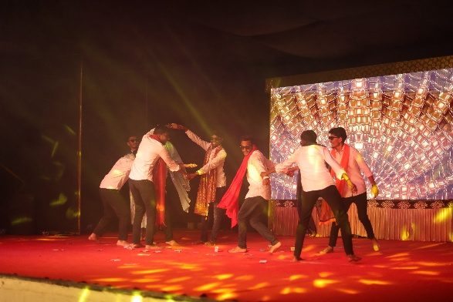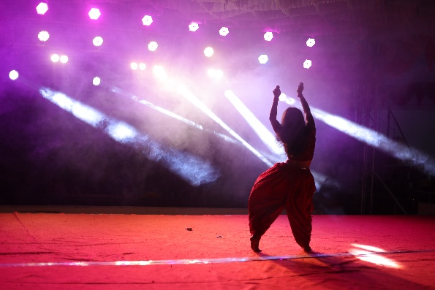

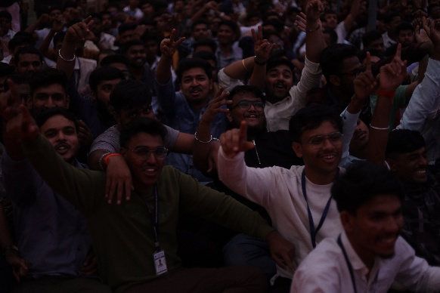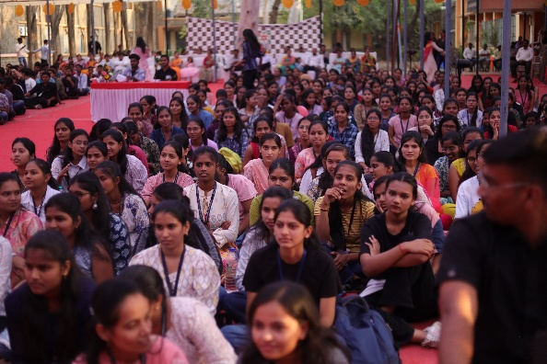

* **6th March 2025:**

On 6th March 2025, the AI-Blockchain Club of the IT Department, GCEK, successfully organized Technocraft, a technical poster presentation competition. The event served as a platform for students to showcase their innovative ideas and research in emerging technologies. Participants presented posters covering diverse domains such as AI, Blockchain, Cybersecurity, IoT, and more. The competition encouraged creativity, technical understanding, and effective communication among budding engineers.

Pixel Club actively covered the event, capturing the intellect and innovation on display through their lenses. From technical illustrations to the focused expressions of participants explaining their concepts, every frame highlighted the academic essence of Technocraft. The coverage helped preserve the knowledge-driven spirit of the event, contributing to the legacy of student-led technical excellence at GCEK.

**Some Photographs:**

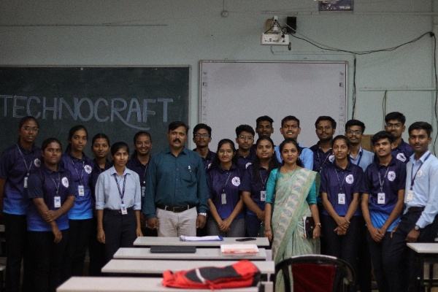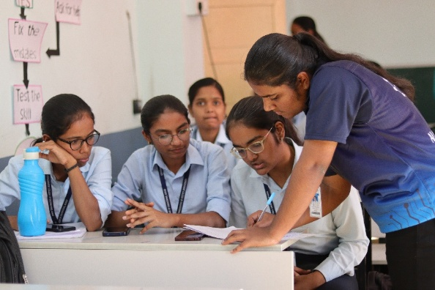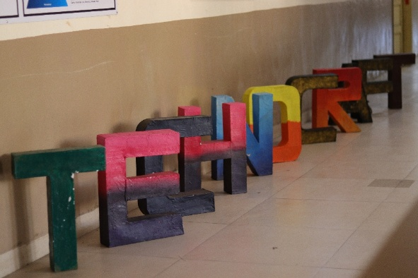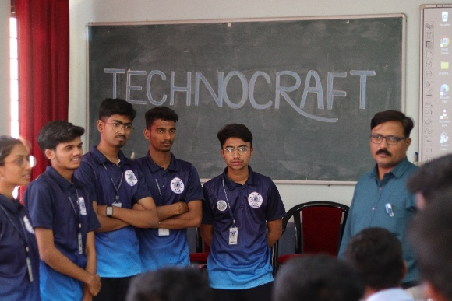

* **8th March 2025:**

On 8th March 2025, Government College of Engineering, Karad (GCEK) celebrated International Women’s Day with great enthusiasm and respect. The event honored the strength, achievements, and contributions of women in all walks of life. Inspirational speeches, cultural performances, and heartfelt acknowledgments made the event memorable. Faculty members and students came together to express gratitude and appreciation toward the women who make a difference every day.

Pixel Club beautifully captured the warmth and pride of the celebration — from smiles during performances to the powerful words shared on stage. Their photographs reflected the essence of Women’s Day: empowerment, unity, and celebration. The coverage ensured the memorable moments of this special day were preserved with elegance and emotion.

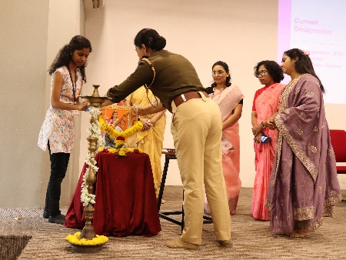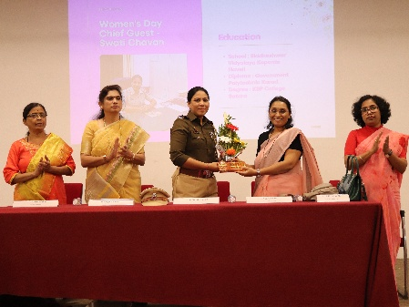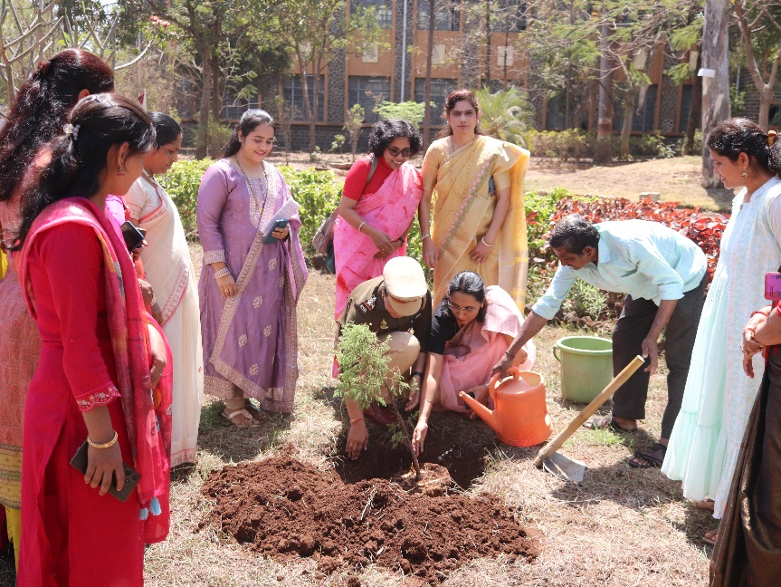

* **CESA Induction Program :**

The **CESA Induction Program** was held at **Government College of Engineering, Karad (GCEK)** to welcome and introduce students to the **Civil Engineering Student Association (CESA)**. The event focused on outlining the objectives, upcoming activities, and opportunities provided by the association. Faculty members and senior students shared insights into how CESA nurtures leadership, technical skills, and teamwork among civil engineering students. The induction served as a bridge to connect new members with the vibrant culture and mission of the association.

**Pixel Club** actively covered the entire event, capturing the essence of interaction, enthusiasm, and unity among students and faculty. From the formal sessions to candid moments, their photography beautifully documented the spirit of CESA. The visual coverage added a creative dimension to the induction, highlighting the beginning of a new chapter for budding civil engineers at GCEK.

Some Photographs:

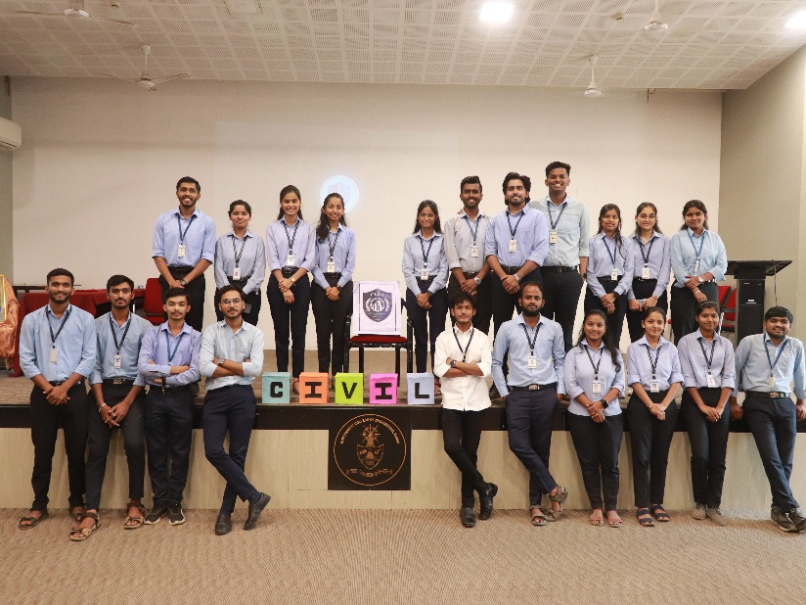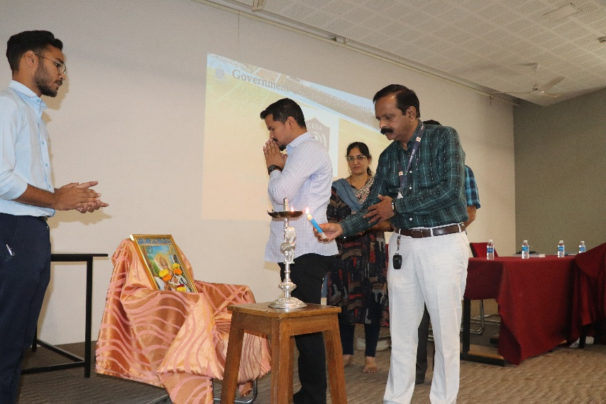

* **ITSA Induction:**

The ITSA Induction Program was successfully organized at Government College of Engineering, Karad (GCEK) to formally welcome students into the Information Technology Students’ Association (ITSA). The event introduced students to the vision, goals, and upcoming initiatives of the association, aiming to build a strong community of tech enthusiasts. Faculty advisors and senior students shared their experiences, inspiring juniors to actively participate in events, workshops, and activities that promote technical growth and collaboration.

Pixel Club captured the energy and enthusiasm of the event with their creative lens. From the engaging speeches to cheerful group moments, every highlight of the induction was beautifully framed. Their photography helped reflect the spirit of unity and innovation that ITSA stands for, preserving the memories of a meaningful and motivating start for IT students.

Some Photographs:

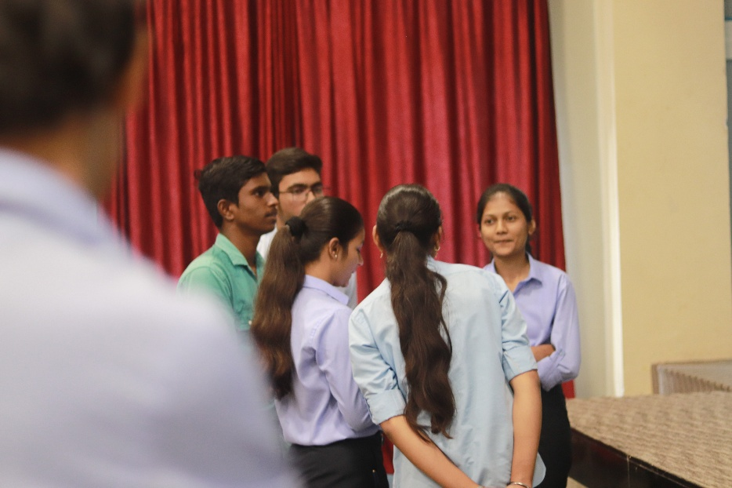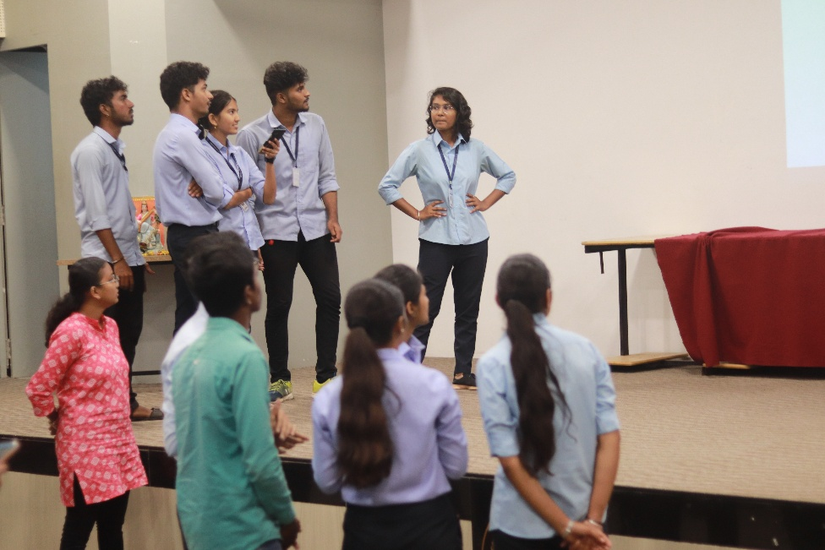

* **Magazine Photoshoot**

The Magazine Photoshoot was an exclusive and vibrant session held to capture the essence of student life, academic excellence, and campus culture at Government College of Engineering, Karad (GCEK). Organized in coordination with the editorial team, the photoshoot featured faculty members, top-performing students, and active club members who contribute to the magazine content. The session aimed to visually represent the year-round achievements and creativity of the GCEK community.

Pixel Club skillfully managed the photography setup, ensuring professional quality portraits and group shots that align with the magazine’s design theme. From lighting arrangements to candid moments, every detail was curated to bring out the personality and story of the subjects, contributing to a visually engaging edition of the annual magazine.

